CloudTrail and CloudWatch Task
Task 1: Enable CloudTrail and Store Events in S3 and CloudWatch Logs
Step 1: Create an S3 Bucket
Open
AWS Console → S3 → Create Bucket
Example
Bucket Name
narayana-cloudtrail-logs
Choose Region
Same Region as your CloudTrail
Leave everything default.
Click
Create Bucket
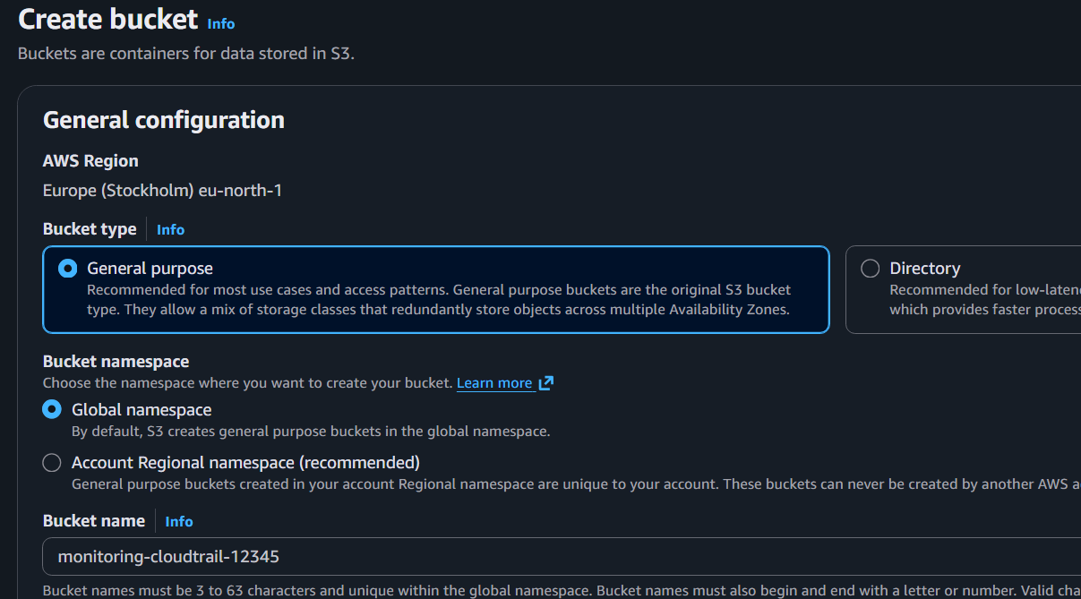

Step 2: Create a CloudWatch Log Group
Go to
CloudWatch
Select
Logs
Click
Create Log Group
Name
CloudTrailLogs
Create.
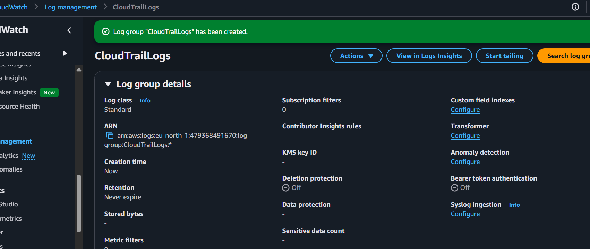

Step 3: Create IAM Role for CloudTrail
Go to
IAM
Create Role
Trusted Entity
AWS Service
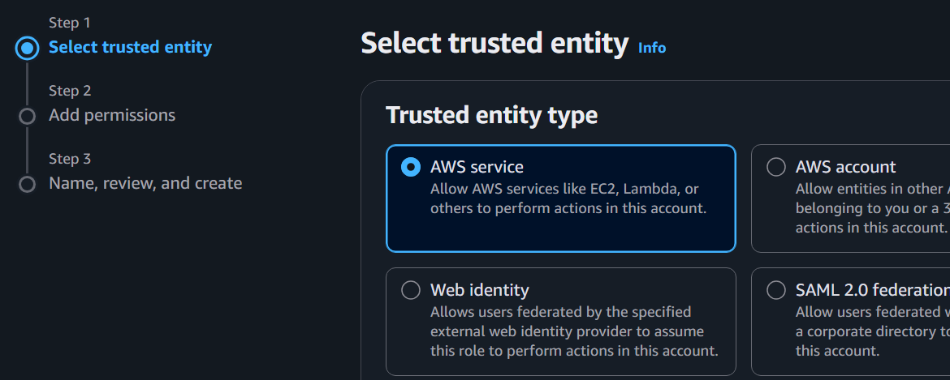

Use Case
CloudTrail
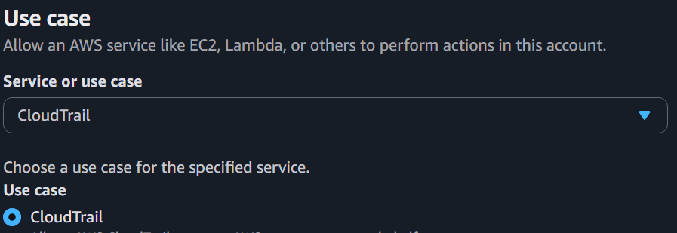
Attach Policy
CloudWatchLogsFullAccess
But by default cloudtrailservicerolepolicy is attached you can’t edit it aws managed
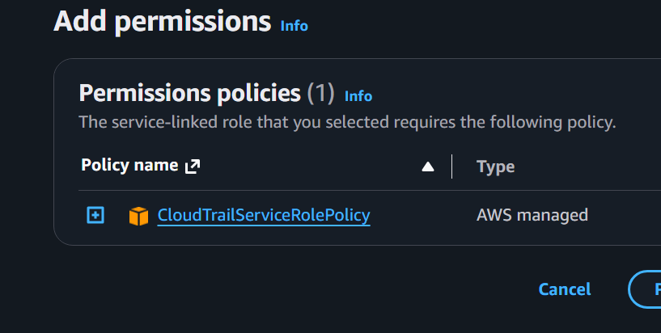
You are at the Add permissions step while creating the CloudTrail role.
You are seeing:
Policy name:
CloudTrailServiceRolePolicy

Type:
AWS managed
This is normal. AWS is creating a CloudTrail service-linked role.
For this lab, do the following:
Step 1: Keep the default policy
Leave:
✅ CloudTrailServiceRolePolicy
selected.
Click:
Next
Step 2: Role name
Enter:
CloudTrailCWRole
Click: Create role
Important note
Earlier I suggested attaching:
CloudWatchLogsFullAccess
manually. The screen you are on is showing the CloudTrail service-linked role flow, which automatically attaches:
CloudTrailServiceRolePolicy

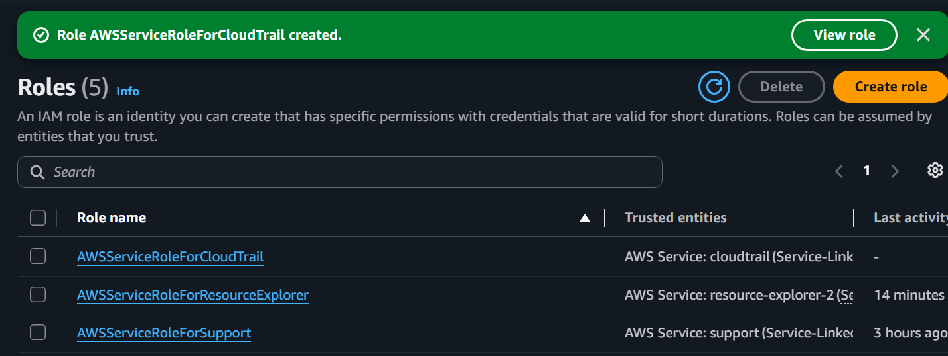
For sending CloudTrail logs to CloudWatch Logs, AWS also needs permissions to write logs. If the trail creation wizard later asks for an IAM role for CloudWatch Logs, we will create/use a role with:
- CloudWatchLogsFullAccess
So continue with the current screen.

Step 4: Create CloudTrail
Go to
CloudTrail
Click
Create Trail
Trail Name
MonitoringTrail
Storage Location
Existing S3 Bucket
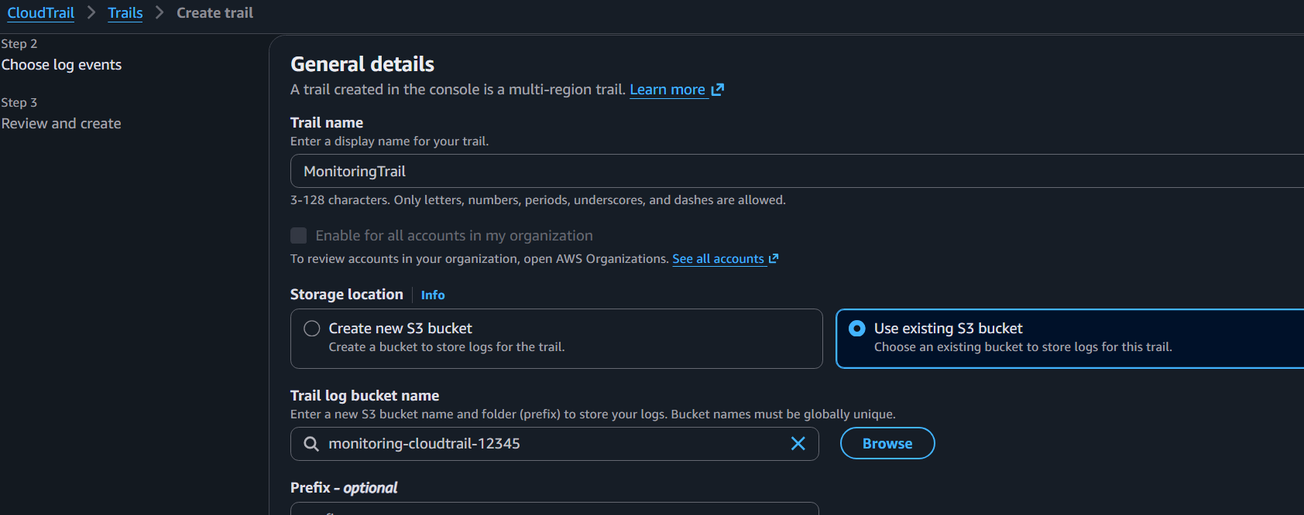
Select
monitoring-cloudtrail-12345
Enable
CloudWatch Logs
Select
CloudTrailLogs
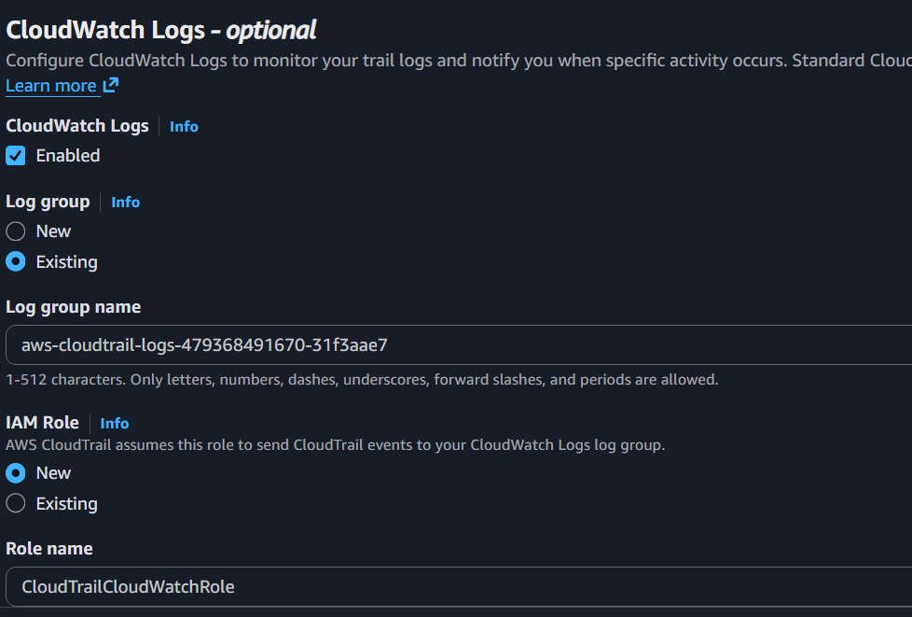
IAM Role
CloudTrailCloudWatchRole
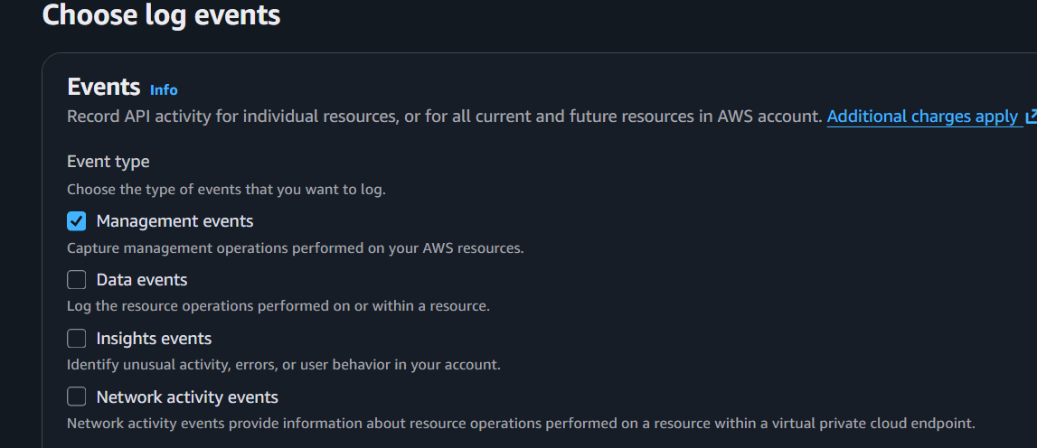
Create Trail.
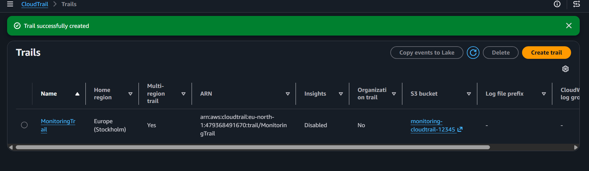

Step 5: Verify
Open
CloudTrail
Choose
Event History
You should see events such as
- Console Login
- StartInstances
- StopInstances
- CreateBucket
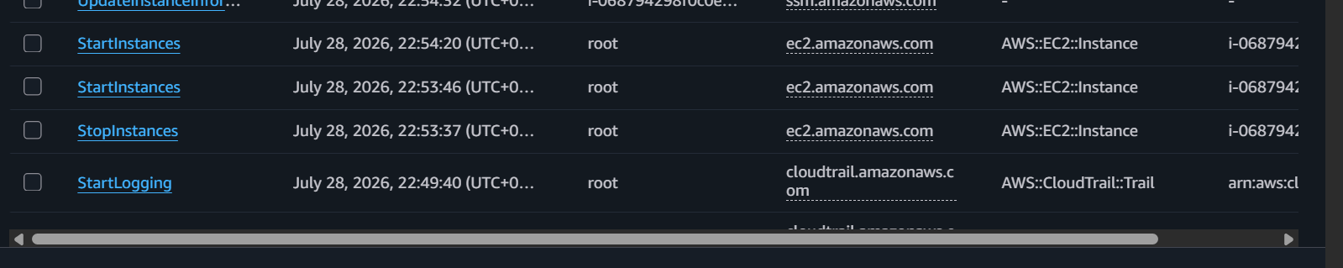
Also verify
S3
contains CloudTrail logs.
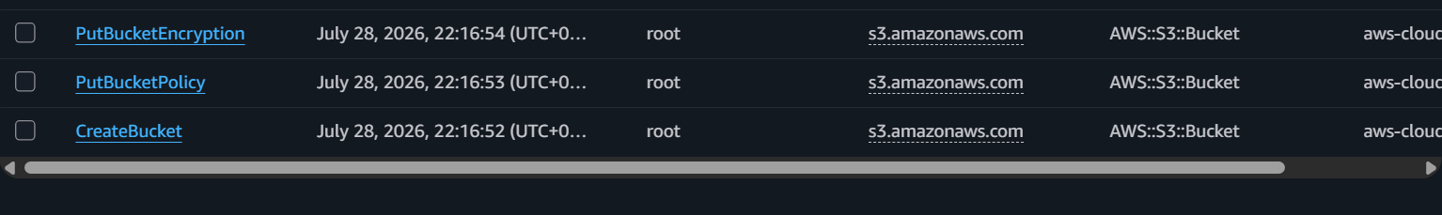
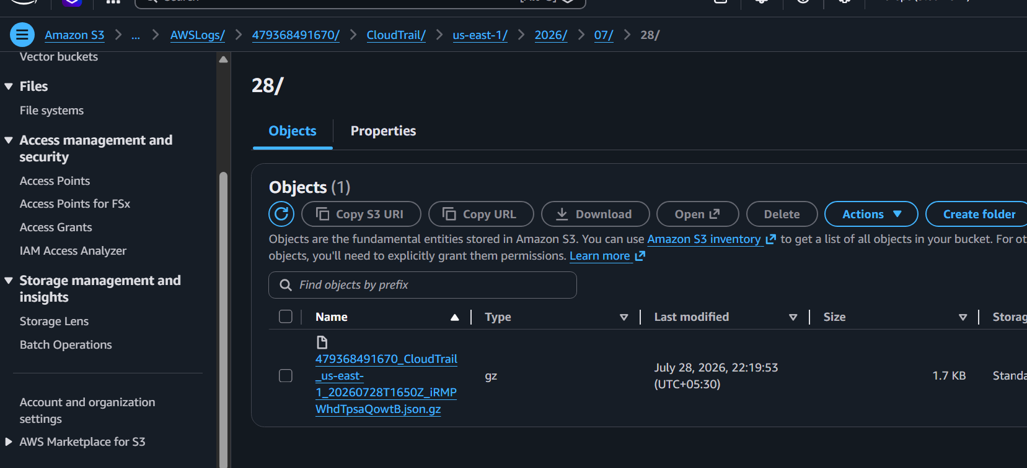
Check CloudWatch Logs
Go to:
CloudWatch
→ Logs
→ Log groups

Open:
aws-cloudtrail-logs-479368491670-31f3aae7
You should see log streams.
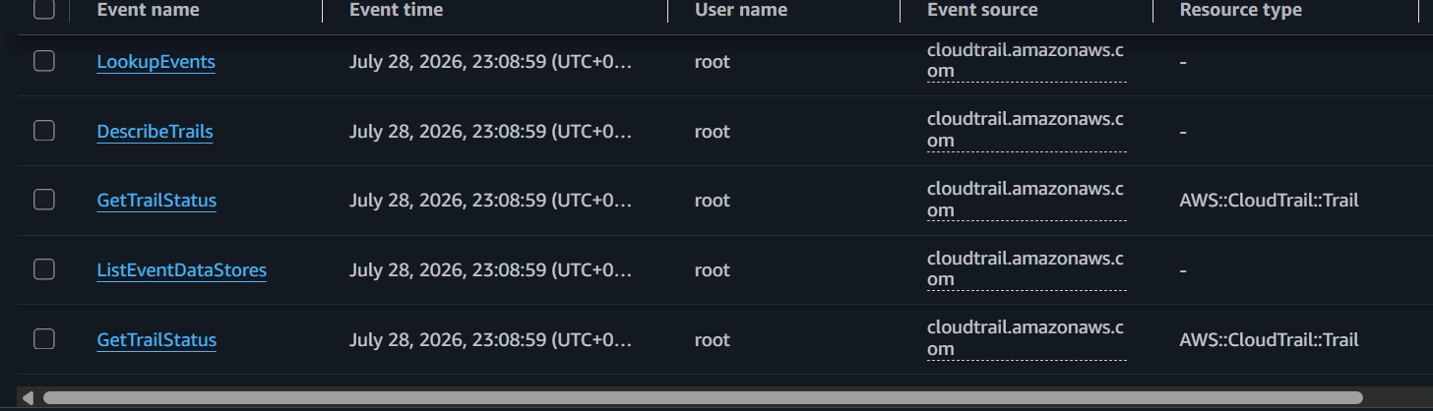
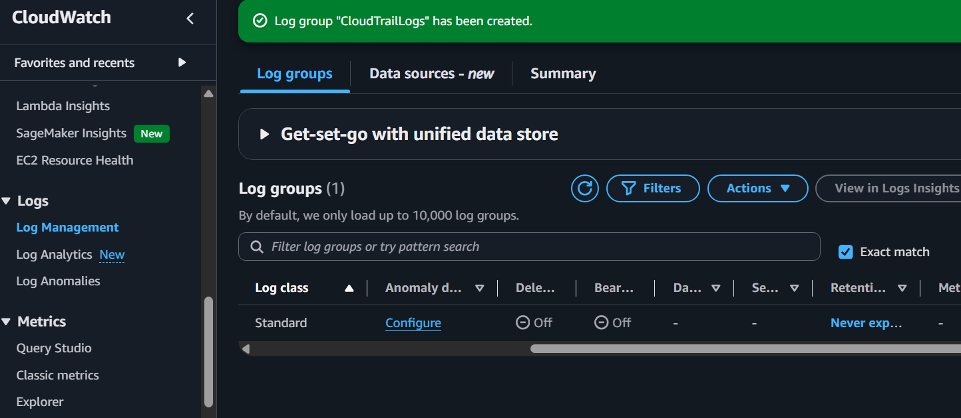

Task 2: Enable SNS for CloudTrail to Send Email Alerts
Architecture
CloudTrail
│
▼
SNS Topic
│
▼
Email Notification

Step 2.1: Create an SNS Topic
- Open the AWS Console.
- Search for SNS and open Amazon Simple Notification Service.
- In the left menu, click Topics.
- Click Create topic.
Configure:
Setting | Value
Type | Standard
Name | CloudTrailAlerts
Leave the remaining settings as default and click Create topic.
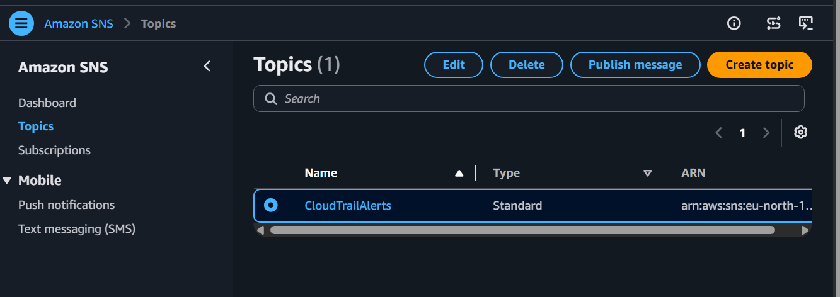
Step 2.2: Create an Email Subscription
- Open the CloudTrailAlerts topic.
- Click Create subscription.
Configure:
Setting | Value
Protocol | Email
Endpoint | Your email address
Example:
yourname@gmail.com
Click Create subscription.
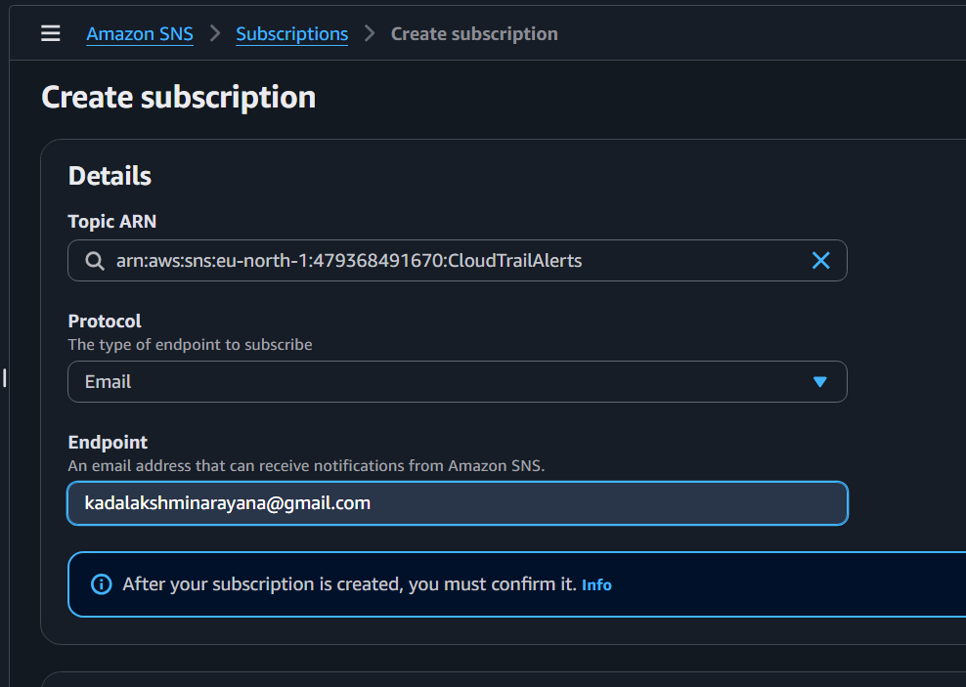

Step 2.3: Confirm the Subscription
- Check your email inbox.
- Open the email from AWS SNS.
- Click Confirm subscription.
Back in the SNS console, the subscription status should change from:
Pending confirmation to Confirmed
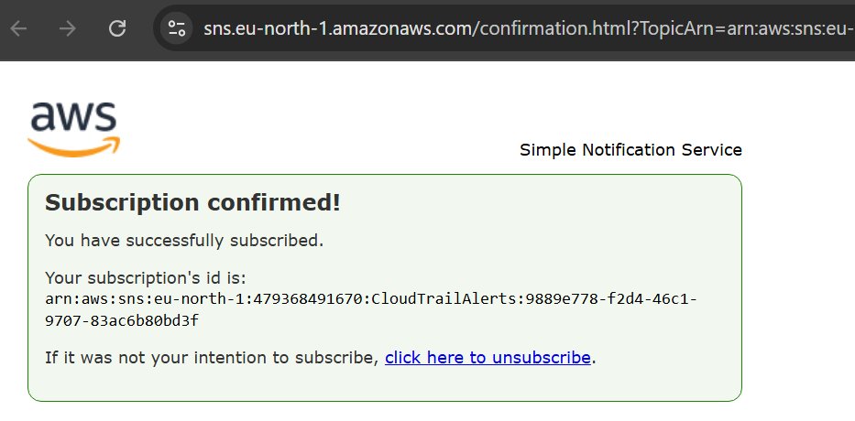
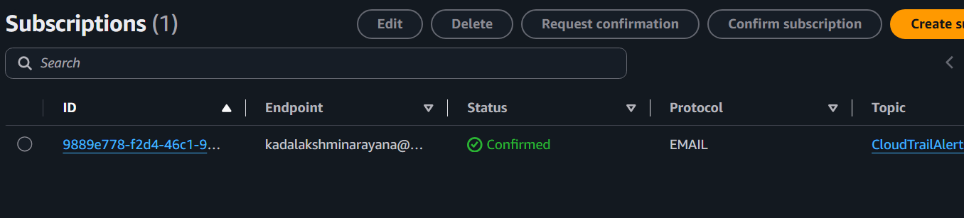
Step 2.4: Connect SNS to CloudTrail
- Go to CloudTrail → Trails.
- Open MonitoringTrail.
- Click Edit.
- In the SNS notification delivery section:
  - Enable SNS notifications (if not already enabled).
  - Select the topic CloudTrailAlerts.
- Save the changes.
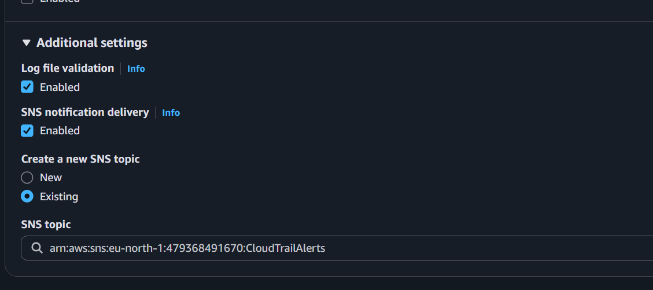

Step 2.5: Test the Notification
Generate a CloudTrail event by performing an AWS action, such as:
- Stop and start your EC2 instance.
- Or run:
aws ec2 describe-instances --region eu-north-1
CloudTrail will deliver a new log file to S3, and SNS should send an email notification.

Expected Result
You should receive an email similar to:
Amazon SNS Notification
A new CloudTrail log file has been delivered. 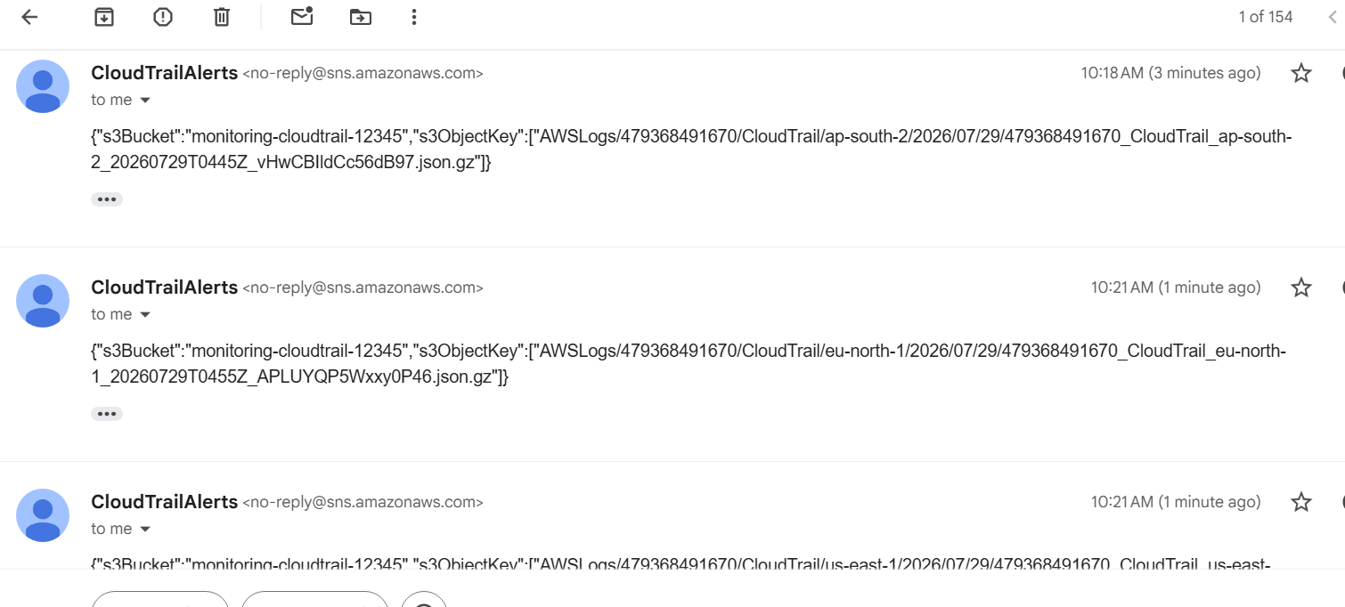
CloudTrail → MyCloudTrail
Expected:
SNS Notification Delivery
Enabled
AWS CLI Verification
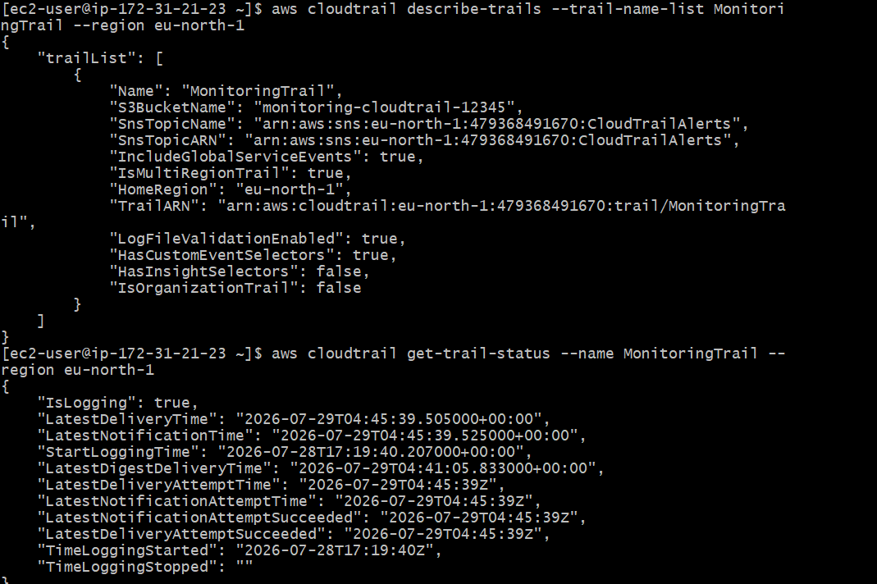
Task 3: Configure CloudWatch Monitoring for EC2
Objective: Monitor your EC2 instance's CPU utilization and other metrics.
What you'll monitor
Default EC2 metrics (available without installing an agent):
- CPU Utilization
- Network In
- Network Out
- Disk Read Bytes
- Disk Write Bytes
- Disk Read Operations
- Disk Write Operations
- Status Check Failed
Additional metrics (require the CloudWatch Agent):
- Memory utilization
- Disk utilization
Since your EC2 instance already has the CloudWatchAgentRole attached, you're in a good position to continue.
Step 1: Verify the CloudWatch Agent
SSH into your EC2 instance and run:
sudo systemctl status amazon-cloudwatch-agent
If it is running, you'll see something like:
Active: active (running)
If it's not installed or not running, you'll see:
Unit amazon-cloudwatch-agent.service could not be found
or
Active: inactive (dead)
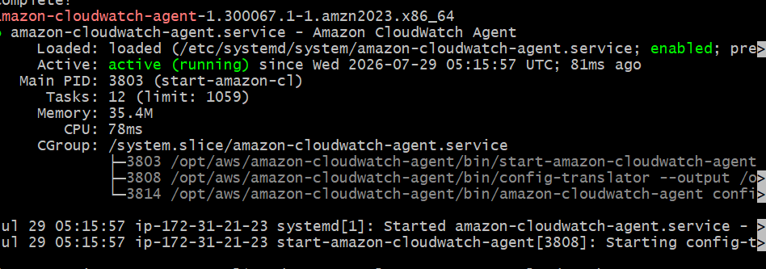

Step 2: Verify EC2 Metrics in CloudWatch
- Open the AWS Console.
- Go to CloudWatch.
- In the left menu, click Metrics.
- Select:
Classic metrics
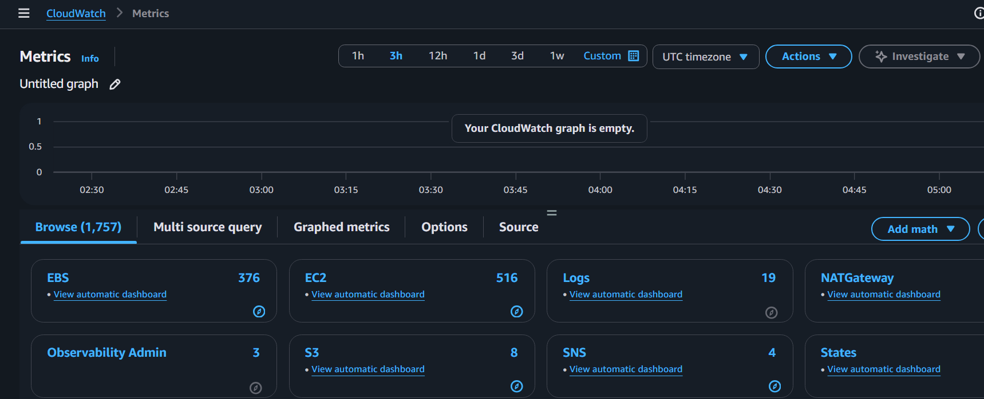
- Click: EC2
- Click: Per-Instance Metrics
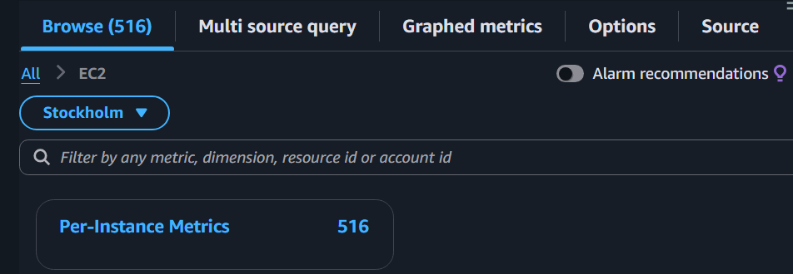
- Select your instance:
i-068794298f0c0e7dc
You should see metrics such as:
- CPUUtilization
- NetworkIn
- NetworkOut
- DiskReadBytes
- DiskWriteBytes
- StatusCheckFailed
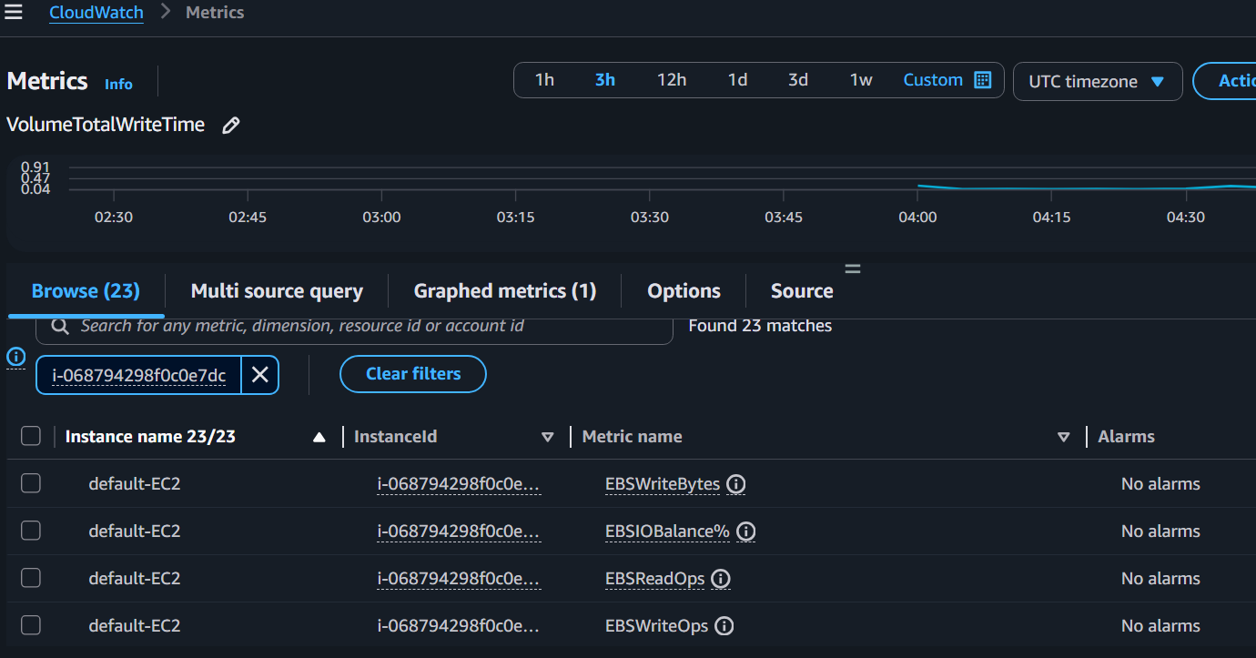
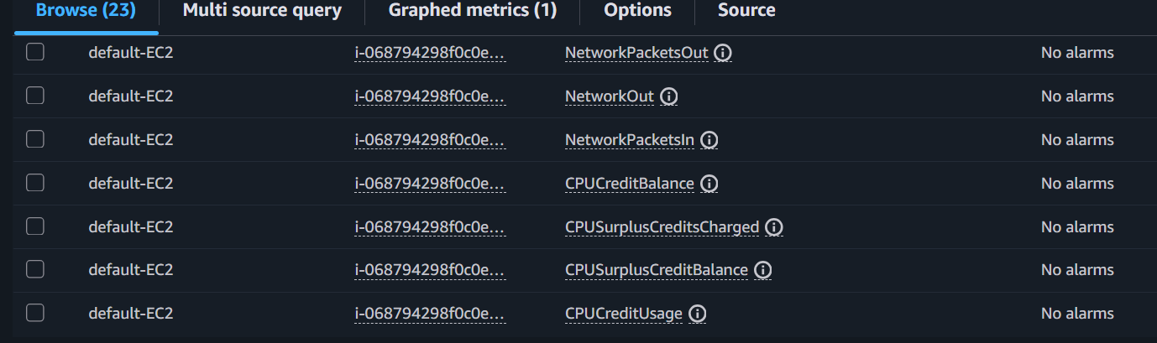
Cpu utilization select metric name cpu utilization
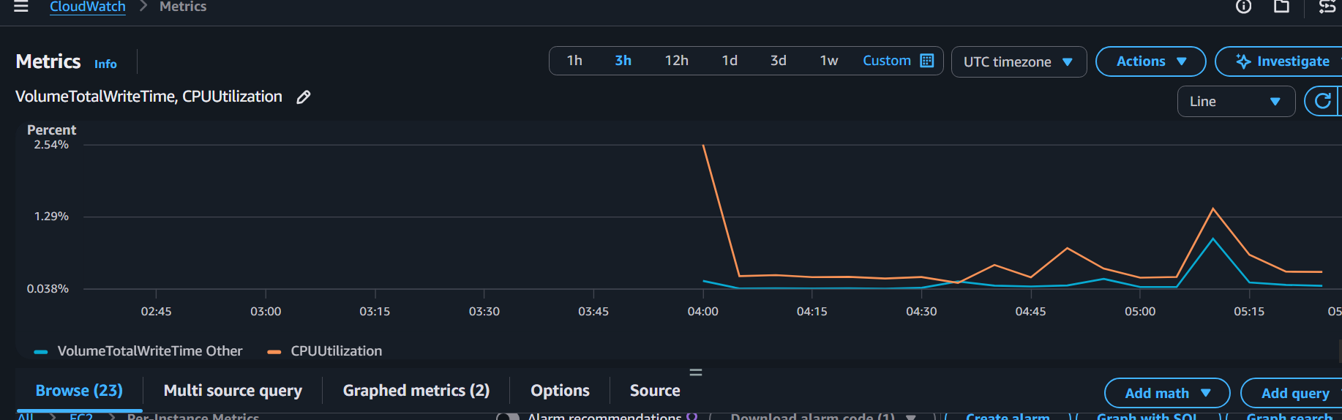

Step 3: Enable Detailed Monitoring (Optional but Recommended)
Currently, your instance has:
Monitoring: disabled
This means CloudWatch collects metrics every 5 minutes.
To collect metrics every 1 minute:
- Go to EC2 → Instances.
- Select your instance.
- Choose: Actions
→ Monitor and troubleshoot
→ Manage detailed monitoring
- Select: Enable
- Save
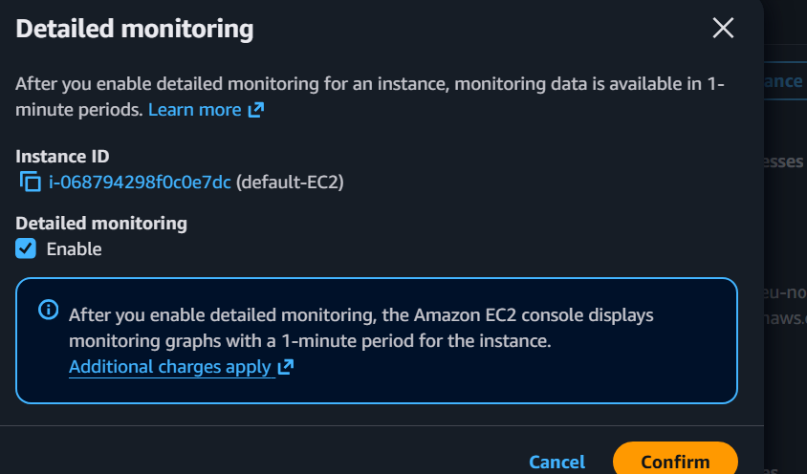
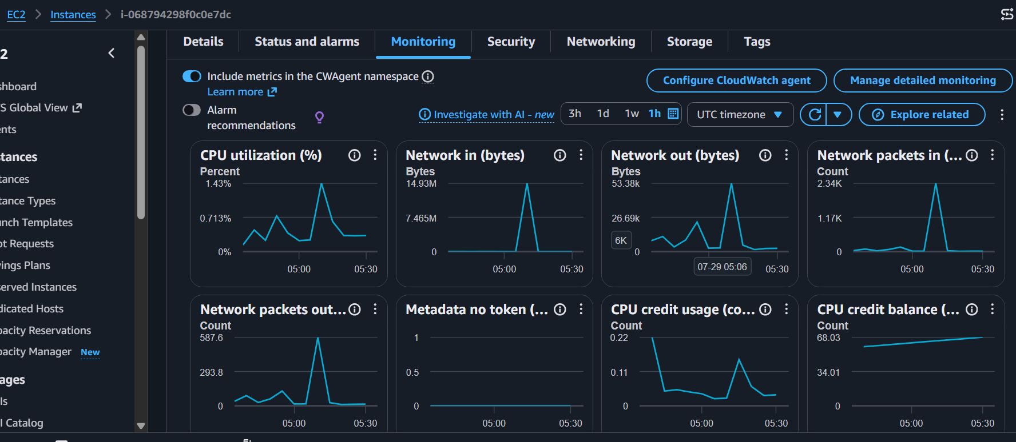
Note: Detailed Monitoring incurs additional CloudWatch charges. For many labs, the default 5-minute monitoring is sufficient unless the lab explicitly requires 1-minute granularity.
Task 4: Create a CloudWatch Alarm for CPU Utilization > 70%
Objective
Create an alarm that sends an email through your existing SNS topic (CloudTrailAlerts) whenever the EC2 instance's CPU utilization exceeds 70%.
Architecture:
EC2 Instance
│
▼
CloudWatch Metric (CPUUtilization)
│
▼
CloudWatch Alarm (>70%)
│
▼
SNS Topic (CloudTrailAlerts)
│
▼
Email Notification

Step 1: Open CloudWatch Alarms
Go to:
CloudWatch
→ Alarms
→ Create alarm
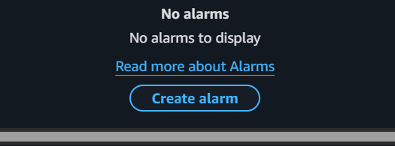

Step 2: Select Metric
Click:
Select metric
Classic
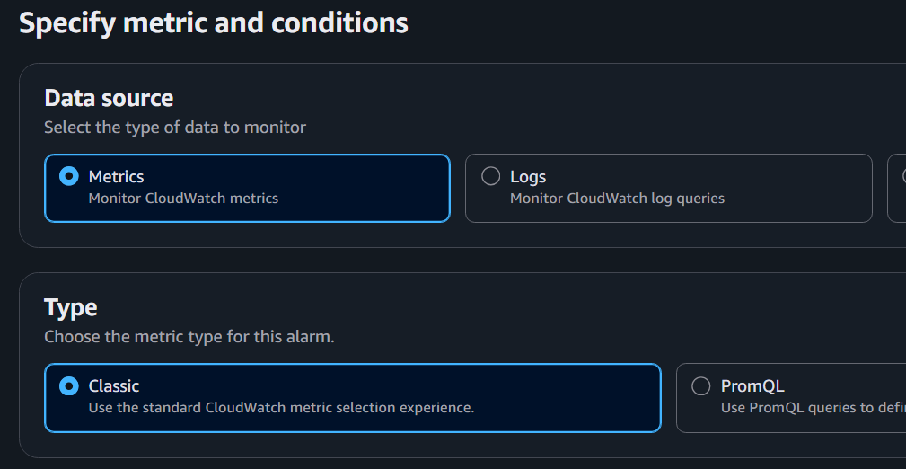
Navigate to:
AWS/EC2
→ Per-Instance Metrics
Select your instance:
i-068794298f0c0e7dc
Choose the metric:
CPUUtilization
Click:
Select metric
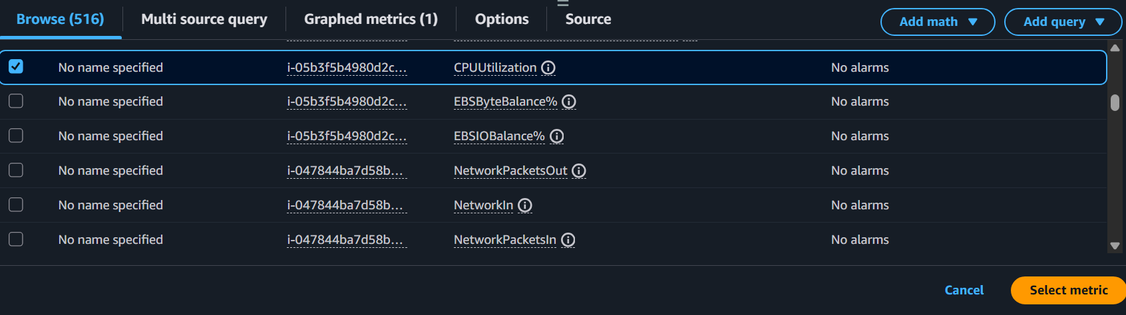

Step 3: Configure Metric
Use these values:
Setting | Value
Statistic | Average
Period | 5 minutes
Threshold type | Static
Condition | Greater
Threshold value | 70
It should read:
CPUUtilization > 70
Click Next.

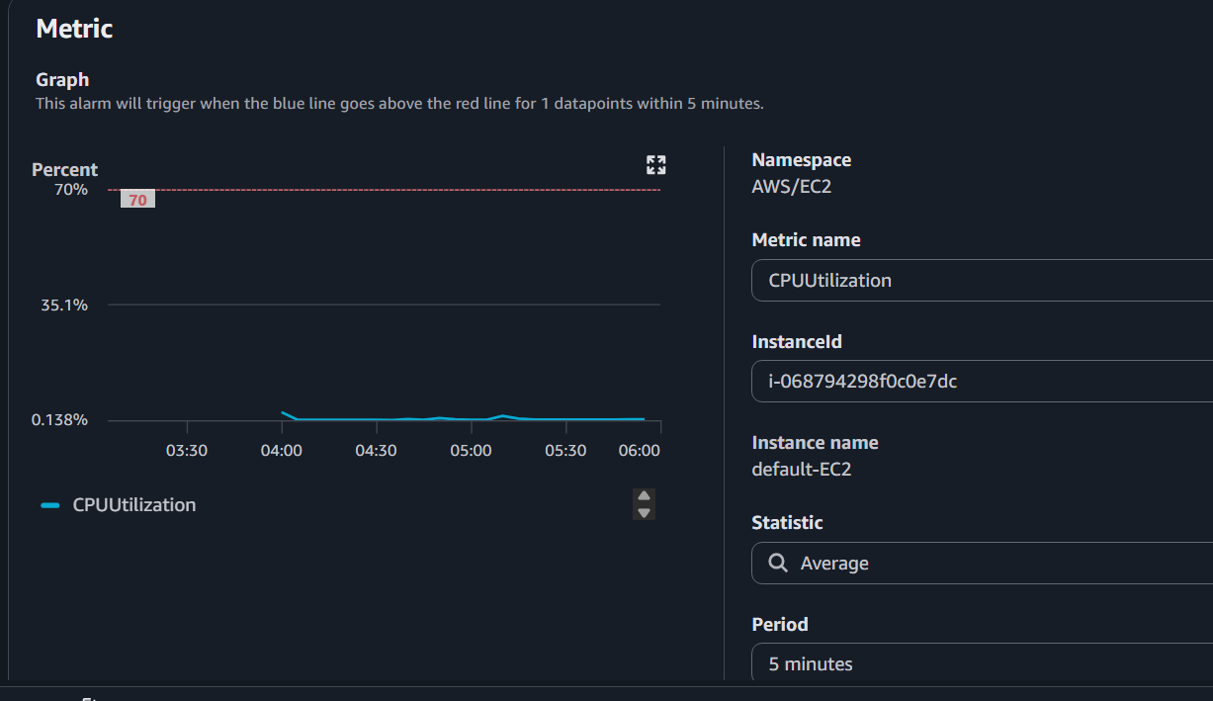
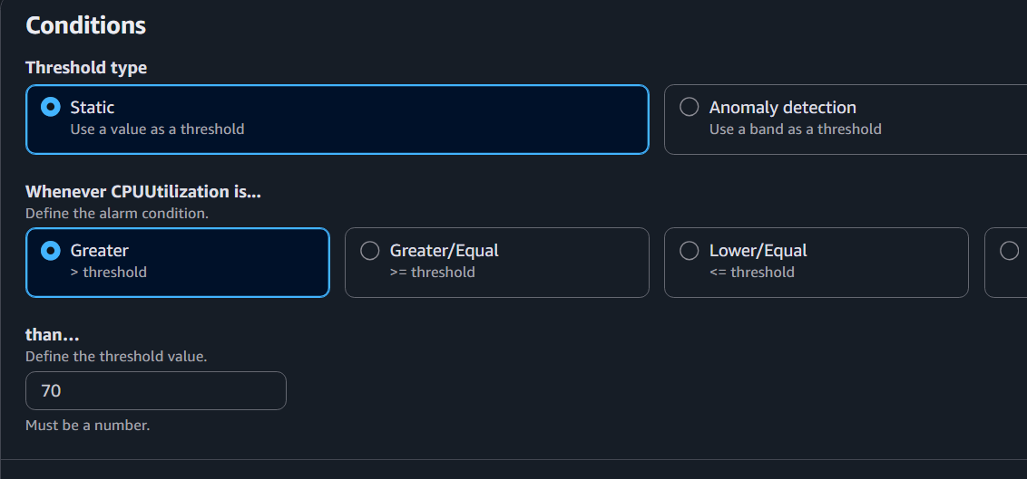

Step 4: Configure Notification
Choose:
In alarm
For SNS topic, select:
CloudTrailAlerts
(Use the same SNS topic you created in Task 2.)
Click Next.
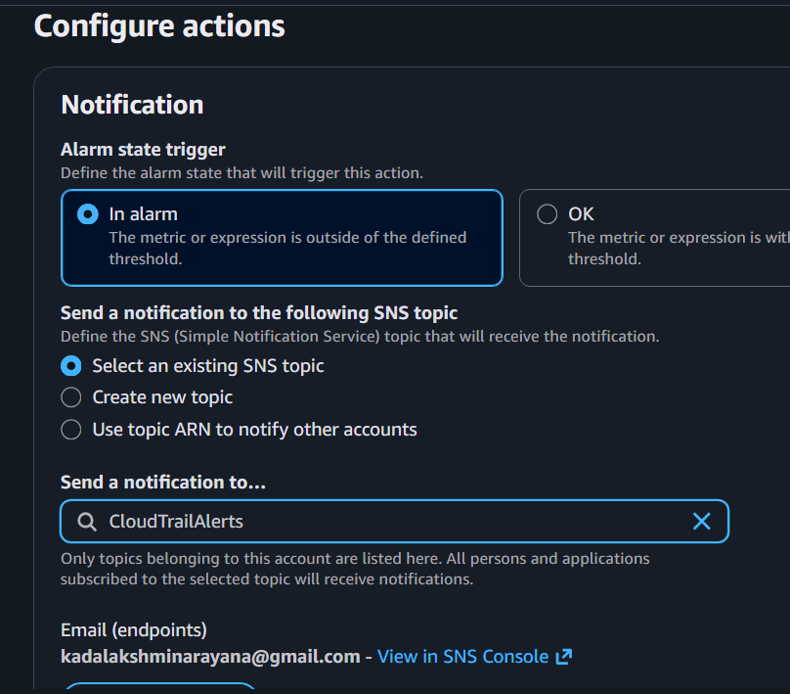

Step 5: Name the Alarm
Alarm name:
EC2-CPU-High
Description (optional):
Send email when EC2 CPU utilization exceeds 70%.
Click:
Next
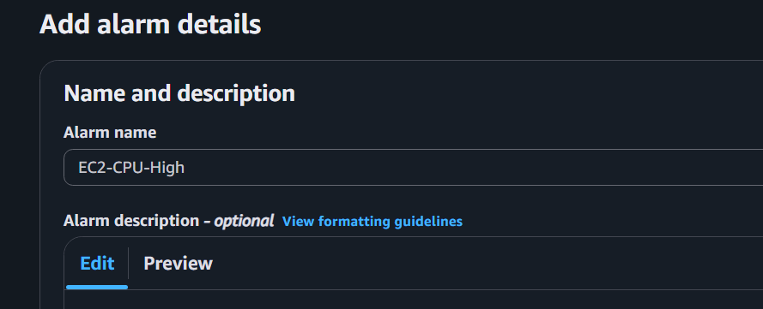
Review everything and click:
Create alarm
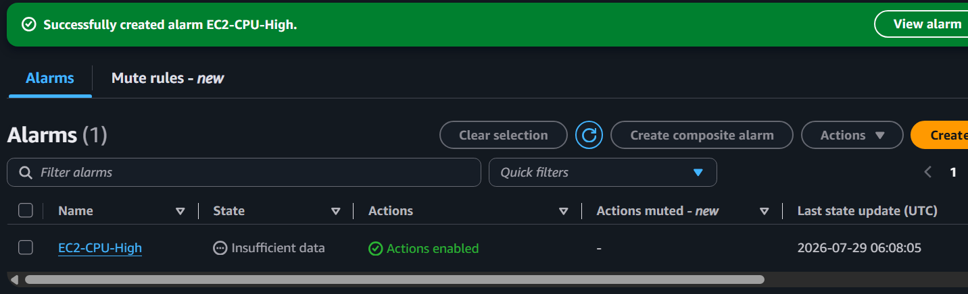

Step 6: Verify the Alarm
Go to:
CloudWatch
→ Alarms
→ All alarms
You should see:
EC2-CPU-High
State: OK
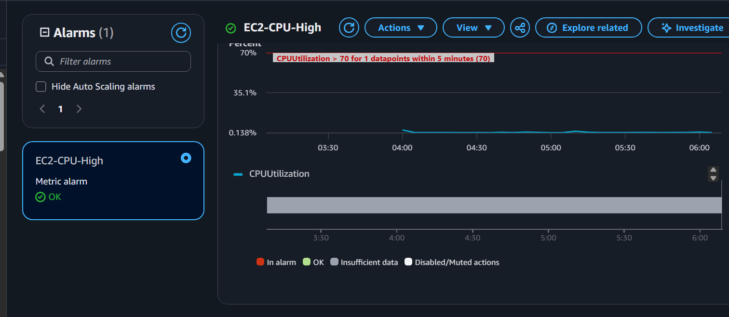

Optional Test
To trigger the alarm, create CPU load on your EC2 instance.
For example, install the stress utility (if available) and run:
sudo dnf install stress -y
stress --cpu 2 --timeout 300
This should increase CPU utilization, and after a few minutes:
Alarm State:
OK
↓
ALARM
You should receive an email from SNS.

Task 5: Create a CloudWatch Dashboard and Monitor the Tomcat Service
Objective
- Create a CloudWatch Dashboard.
- Monitor Tomcat service status.
- Send an email alert if Tomcat stops.

Part 1: Verify Tomcat is Running
SSH into your EC2 instance and run:
ps -ef | grep tomcat
or
sudo ss -tulnp | grep 8080
You should see the Tomcat Java process or port 8080 listening.

Part 2: Create a Script to Publish Tomcat Status
Create the script:
vi ~/tomcat-monitor.sh
Paste the following:
#!/bin/bash
if pgrep -f "org.apache.catalina.startup.Bootstrap" > /dev/null
then
STATUS=1
else
STATUS=0
fi
aws cloudwatch put-metric-data \
--namespace Custom/Tomcat \
--metric-name ServiceStatus \
--value $STATUS \
--unit Count \
--region eu-north-1
Save the file.
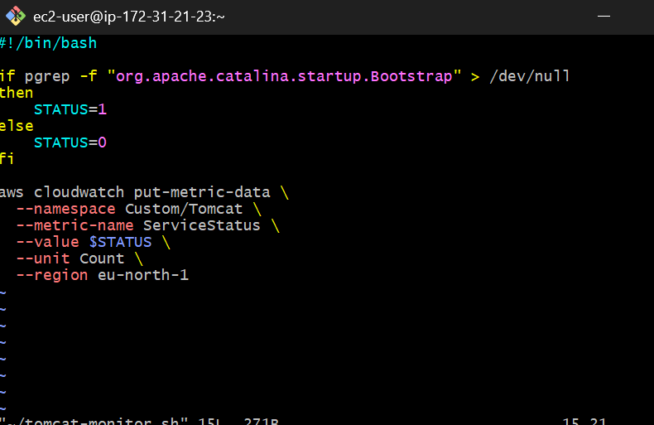

Part 3: Make It Executable
chmod +x ~/tomcat-monitor.sh

Part 4: Run the Script
./tomcat-monitor.sh
There should be no output if it succeeds.
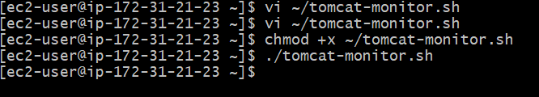

Part 5: Verify the Custom Metric
Wait about 2–3 minutes, then go to:
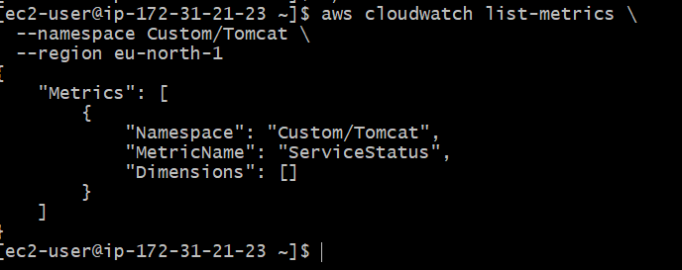
CloudWatch
→ Classic metrics
→ All metrics
→ Custom Namespaces
→ Custom/Tomcat
You should see:
ServiceStatus
Value:
1
means Tomcat is running.

Part 6: Create a CloudWatch Alarm
Go to:
CloudWatch
→ Alarms
→ Create alarm
Choose:
Metrics
Then:
Classic
Click:
Select metric
Navigate to:
Custom Namespaces
→ Custom/Tomcat
→ ServiceStatus
Select the metric.
Click:
Select metric
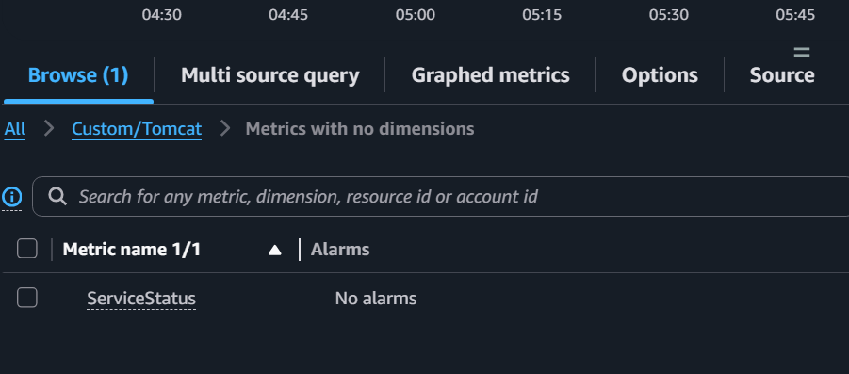

Part 7: Configure the Alarm
Set:
Setting | Value
Statistic | Average
Period | 1 minute
Threshold type | Static
Condition | Lower
Threshold | 1
This means:
Alarm when ServiceStatus < 1
Click Next.
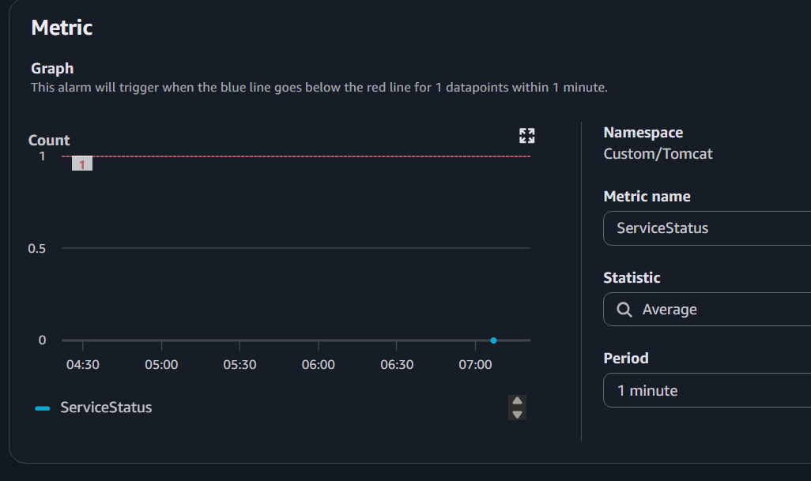

Part 8: Configure Notifications
Choose:
In alarm
Select the existing SNS topic:
CloudTrailAlerts
Click Next.
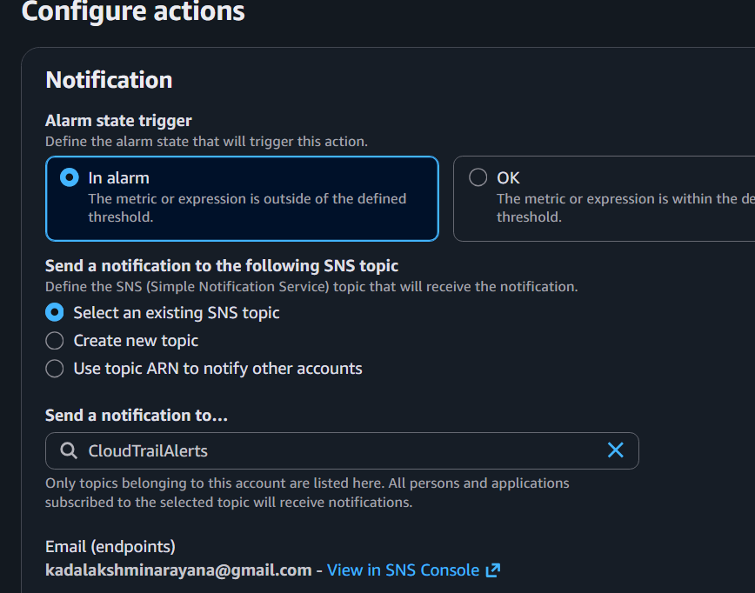

Part 9: Name the Alarm
Alarm name:
Tomcat-Service-Down
Description:
Send an email if the Tomcat service stops.
Click Create alarm.
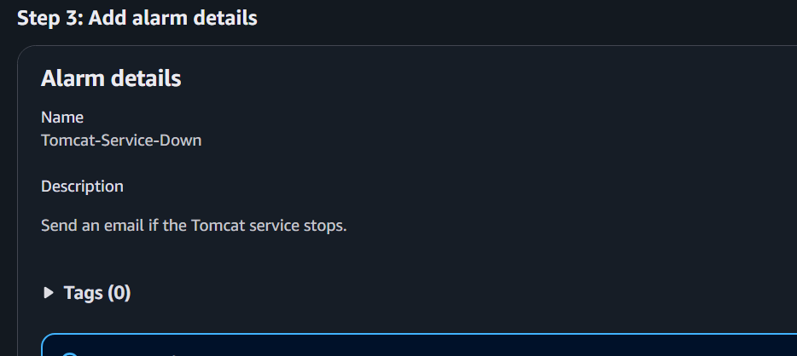

Part 10: Create the Dashboard
Go to:
CloudWatch
→ Dashboards
→ EC2-Monitoring-Dashboard
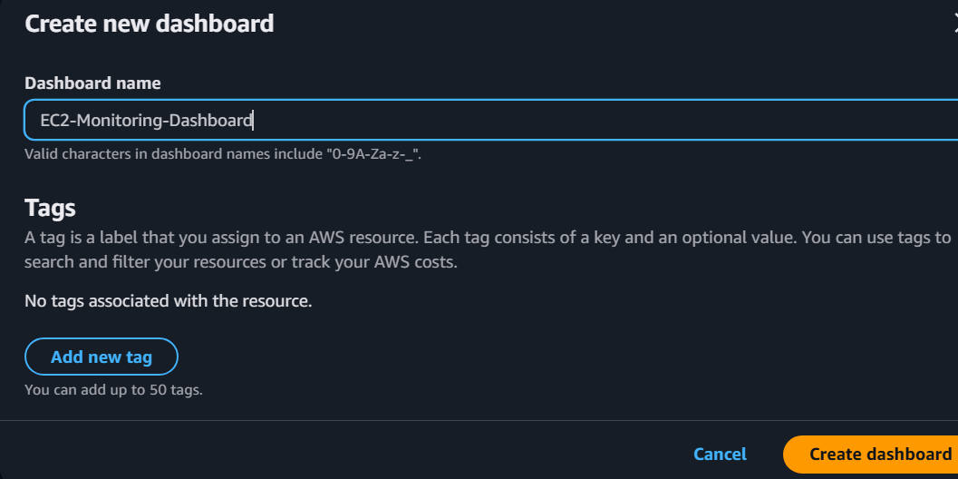
Click:
Add widget
Choose:
Number
Click Next.
Select:
Custom/Tomcat
→ ServiceStatus
Click:
Create widget
The dashboard now displays:
Tomcat Status

1 = Running
0 = Stopped
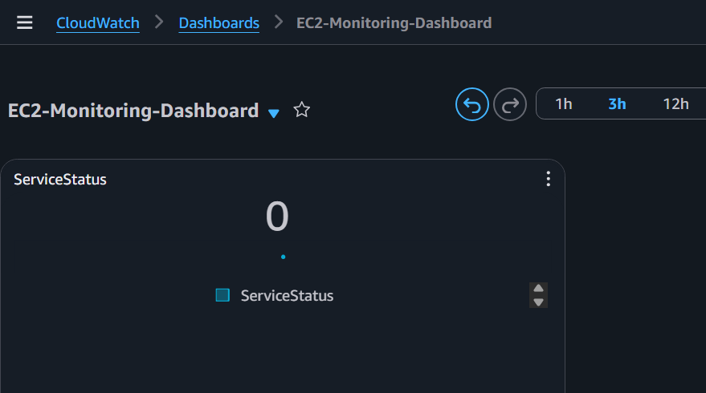

Part 11: Automate the Script
Edit your crontab:
crontab -e
Add:
* * * * * /home/ec2-user/tomcat-monitor.sh
Save and exit.
This publishes the Tomcat status every minute.
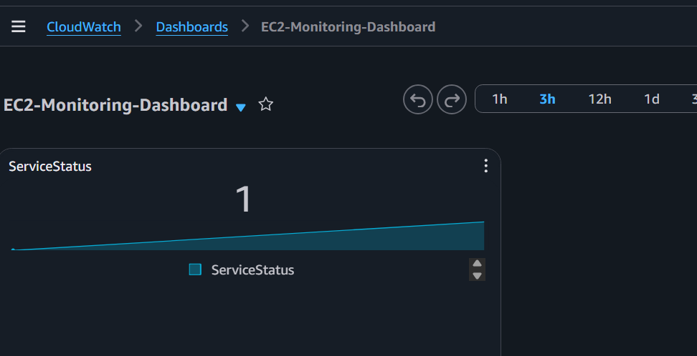

Part 12: Test the Alarm
Stop Tomcat:
pkill -f org.apache.catalina.startup.Bootstrap
Wait 2–3 minutes.
Expected results:
- Dashboard value changes from 1 to 0
- Alarm changes to ALARM
- SNS sends an email notification
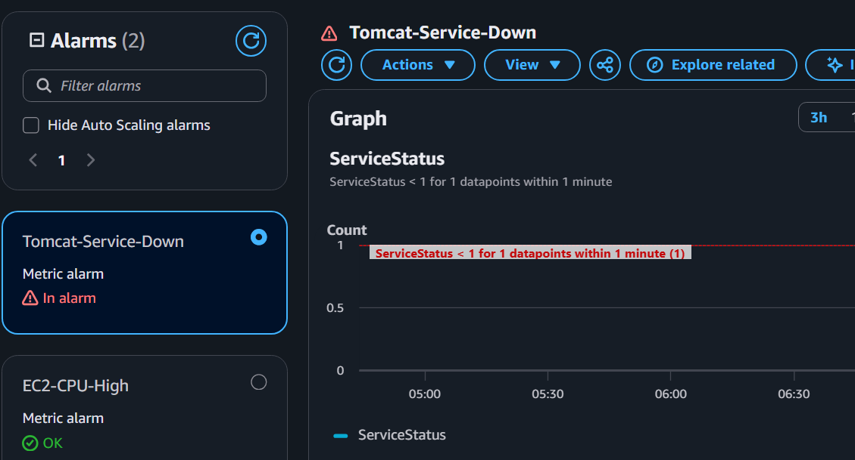
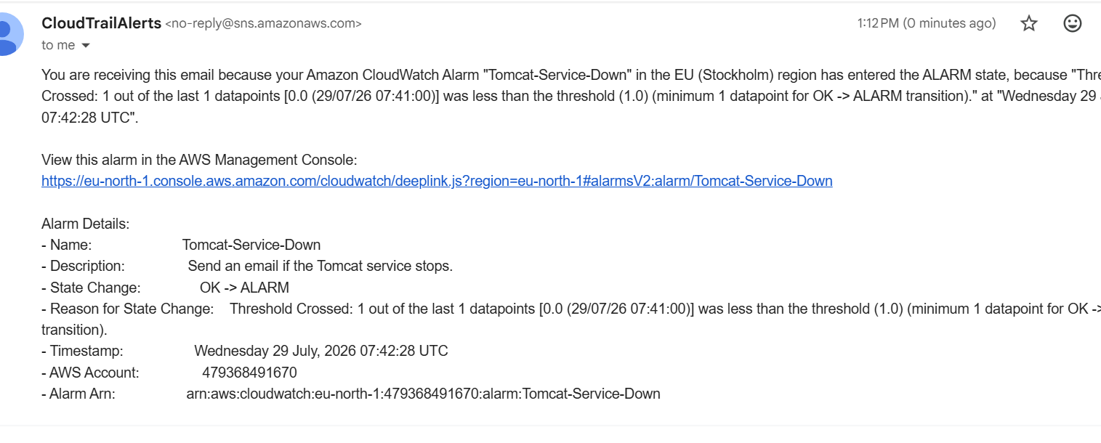
Restart Tomcat:
/opt/tomcat/bin/startup.sh
After the next cron run:
- Dashboard changes back to 1
- Alarm returns to OK
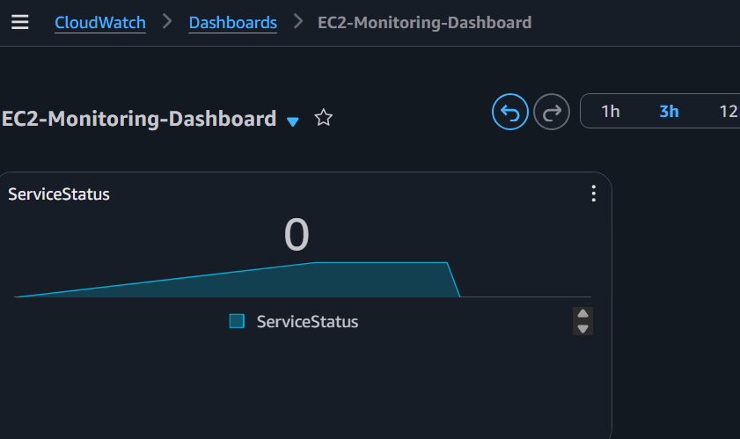

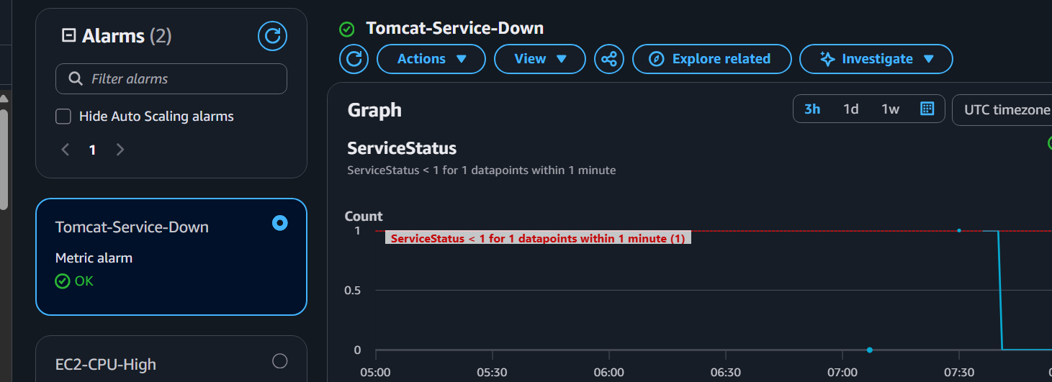
TASK 6 : Create a Dashboard and monitor the Nginx service to send the alert if Nginx is not running.
Step 1: Verify Nginx is running
Run:
sudo systemctl status nginx
Expected:
Active: active (running)
If it's not running:
sudo systemctl start nginx
sudo systemctl enable nginx
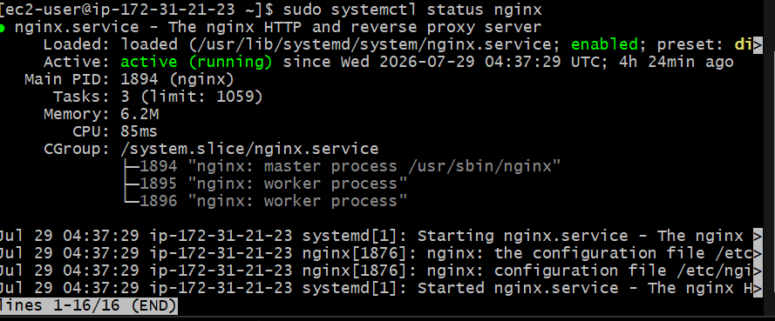

Step 2: Create the Nginx monitoring script
Open a new file:
vi ~/nginx-monitor.sh
Press i and paste:
#!/bin/bash

if systemctl is-active --quiet nginx
then
STATUS=1
else
STATUS=0
fi
aws cloudwatch put-metric-data \
--namespace Custom/Nginx \
--metric-name ServiceStatus \
--value $STATUS \
--unit Count \
--region eu-north-1
Save:
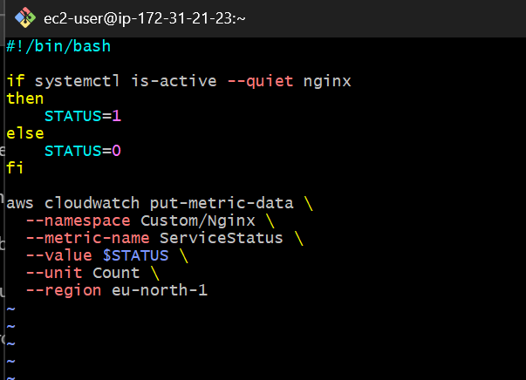

Step 3: Make the script executable
chmod +x ~/nginx-monitor.sh

Step 4: Test the script
./nginx-monitor.sh
There should be no output, which is normal.
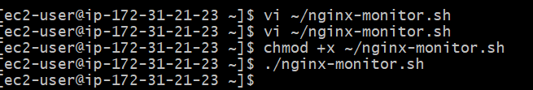

Step 5: Verify the custom metric
Wait about 1 minute, then run:
aws cloudwatch list-metrics \
--namespace Custom/Nginx \
--region eu-north-1
Expected:
MetricName: ServiceStatus
Namespace: Custom/Nginx
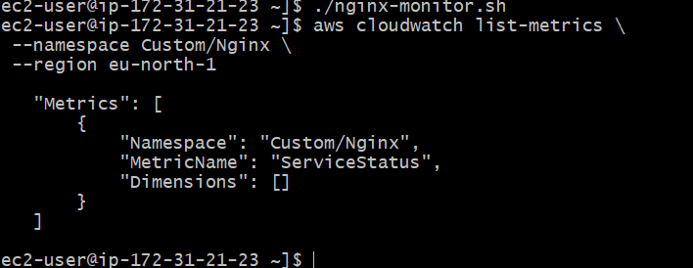

Step 6: Create a cron job
Edit your crontab:
crontab -e
Add this line below your Tomcat cron job:
* * * * * /home/ec2-user/nginx-monitor.sh
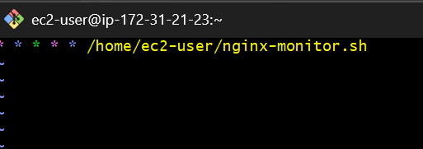
Now crontab -l should show:
* * * * * /home/ec2-user/tomcat-monitor.sh
* * * * * /home/ec2-user/nginx-monitor.sh
Save and exit.
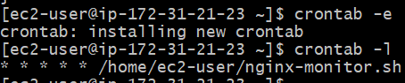

Step 7: Create the CloudWatch Alarm
In the AWS Console:
- Open CloudWatch → Alarms
- Click Create alarm
- Select Metric
- Navigate to:
  - Custom Namespaces
  - Custom/Nginx
  - ServiceStatus
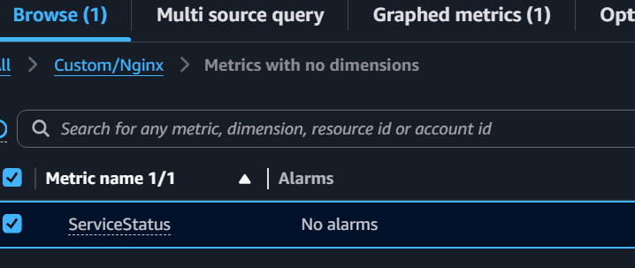
- Configure:
  - Statistic: Average
  - Period: 1 minute
  - Threshold: Lower than 1
  - Evaluation periods: 1
  - Datapoints to alarm: 1 out of 1
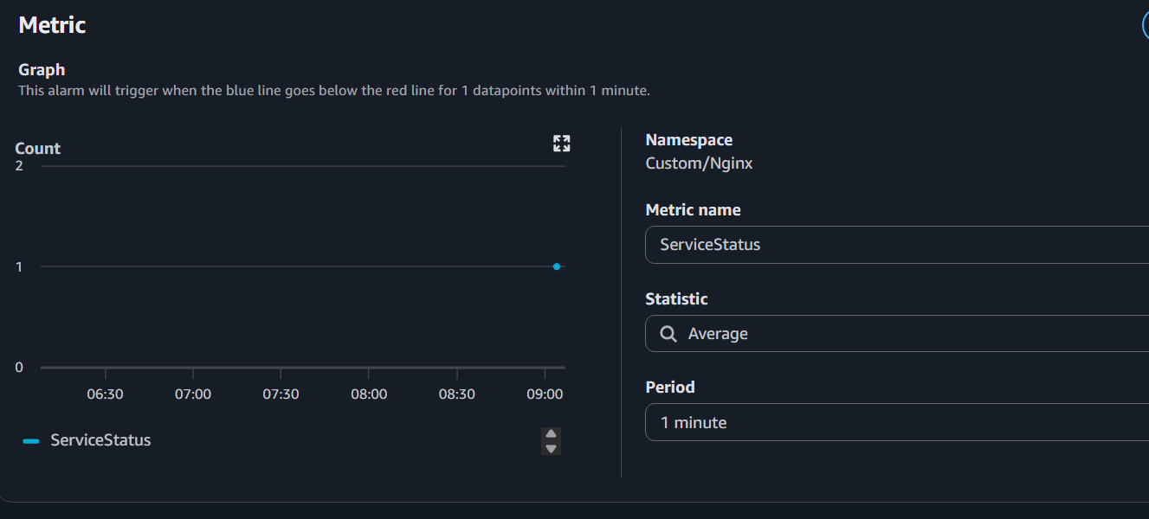
- Select your existing SNS topic:
  - CloudTrailAlerts

- Alarm name:
Nginx-Service-Down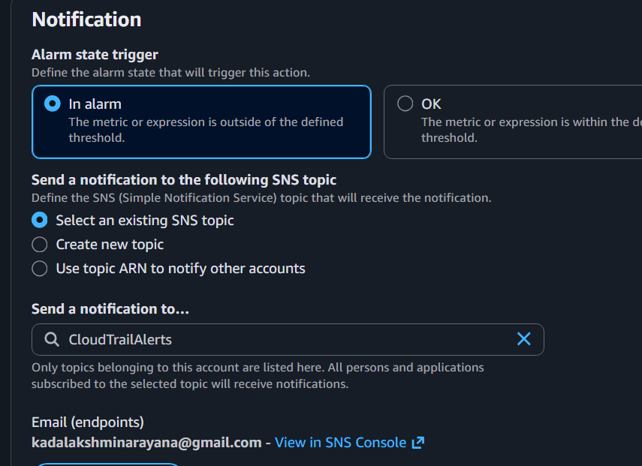
- Create the alarm.
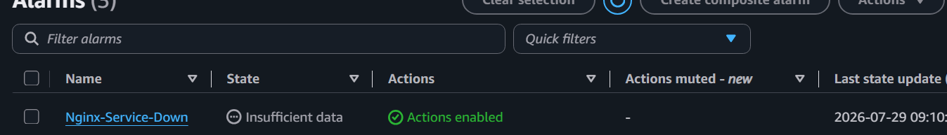
Step 8: Add the metric to your dashboard
- Open CloudWatch → Dashboards
- Open EC2-Monitoring-Dashboard
- Click Edit → Add widget
- Choose Line
- Select:
  - Namespace: Custom/Nginx
  - Metric: ServiceStatus
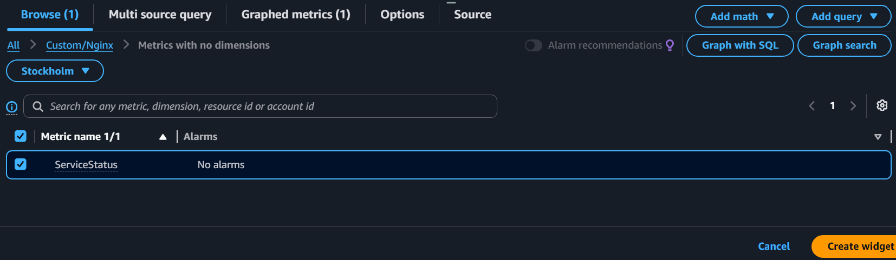
- Set:
  - Period: 1 minute
  - Statistic: Average
- Save the dashboard.
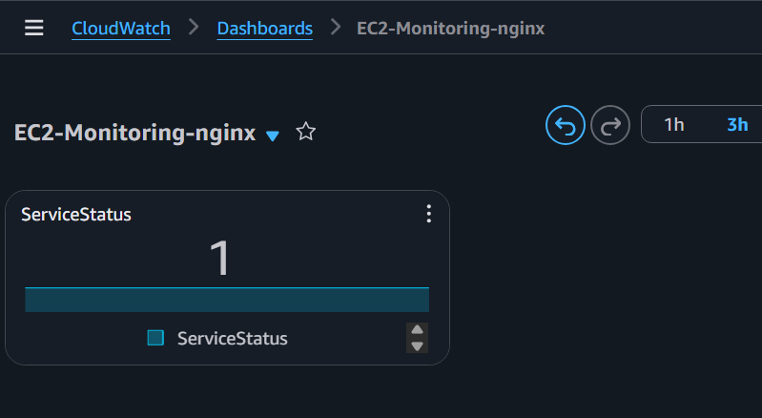

Step 9: Test the alarm
Stop Nginx:
sudo systemctl stop nginx
Wait 2–3 minutes.
Expected:
- Alarm changes to ALARM
- Dashboard shows 0
- SNS email is received
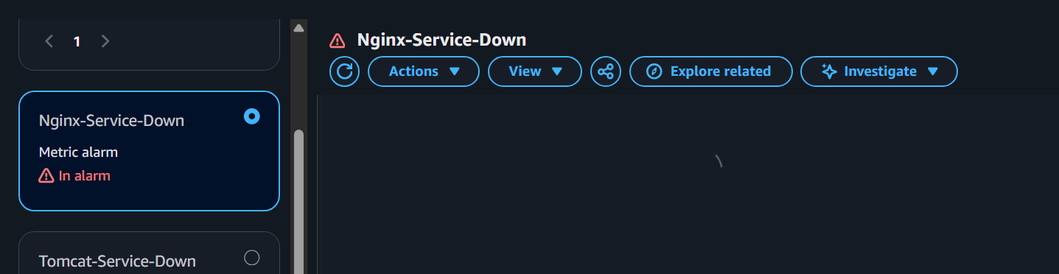
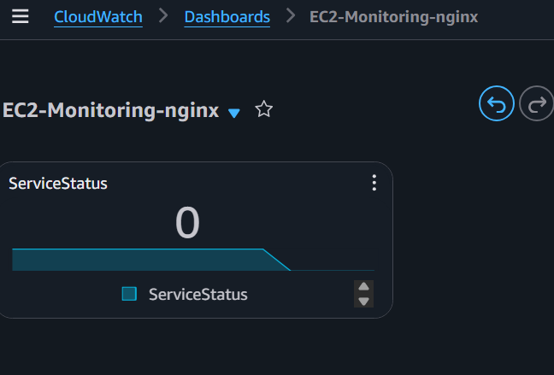
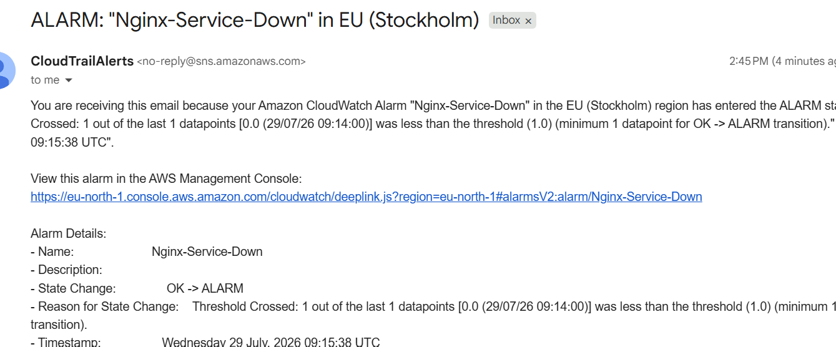
Start Nginx again:
sudo systemctl start nginx
Within another minute or two:
- Alarm returns to OK
- Dashboard shows 1


